Using the WISN Loader

**Step by step guide to use the WISN Loader to conduct a WISN study**

| Ver. No. | Ver. Date | Prepared By | Reviewed By | Review  Date | Affected Section & Summary of Change |
| --- | --- | --- | --- | --- | --- |
| 1.0 | 10/10/2018 | Pierre Kasongo |  |  | Initial document creation |
|  |  |  |  |  |  |

Contents

1 The steps to upload data directly into the WISN software 4

1.1 Background 4

1.2 Getting your data ready 4

1.2.1 Setting up activity standards, category allowance standards and individual allowance standards 4

1.2.2 Setting up your list of facilities 4

1.2.3 Setting up the service statistics 5

1.2.4 Setting up the staff data 5

1.3 Preparing to use the WISN Loader 6

1.3.1 Setting up your template files 6

1.3.2 Running the WISN Loader 8

1.4 Analyzing your WISN files 8

# The steps to upload data directly into the WISN software

## Background

In DRC, we conducted a National WISN for 4 cadres namely doctors, nurses, midwives and laboratory technicians for 164 public health facilities selected in 5 regions. Based on Namibia experience our IT Developer developed a Java applicationto import the service data from Excel and create a WISN file for each facility setup with the required cadres, activity standards, category allowance standards, individual allowance standards, service statistics and current staffing.

## Getting your data ready

This step involves preparing the input files for the NAWL, but can also be used to assess the quality of your data. For each activity, you have to verify whether you can get service statistics or not. If you are not able to get service statistics, you have to convert the activity into either a category or individual allowance standard.

### Setting up activity standards, category allowance standards and individual allowance standards

A prerequisite for this step, is to ensure you have defined all your activities and standards i.e. activity allowance, category allowance standards and individual allowance standards.

Using your pre-defined activities, map each one to a data element and identified data source. This will enable you to confirm the activities you have to convert to category or individual allowance standards and it is good practice to show your data source to anybody looking at your study afterwards. You will also be able to identify applicable units of measures as there are only limited ones available in the WISN tool. This became our **Master Service Standards** file. Whenever changes are made to the activities or service standards in the **Master Service Standards**, the same changes have to be applied to the templates in the next step since the software requires an exact match between the WISN activity in the template and the **Master Service Standard**.

### Setting up your list of facilities

These steps produces an Excel file containing the name of all facilities, the region and district where they are located and their classification type for which you are conducting the WISN study which is the **Master Facility List**.

You must save it as **facilities.xls** or any other name making sure you changed the value in the config file, for use by the Loader that uses it to determine which template to use in the generation of a WISN file per facility. It also uses it to generate the filename for each facility. As for facility types, we had the following set in WISN :

* Hopital
* Soin de sante primaires

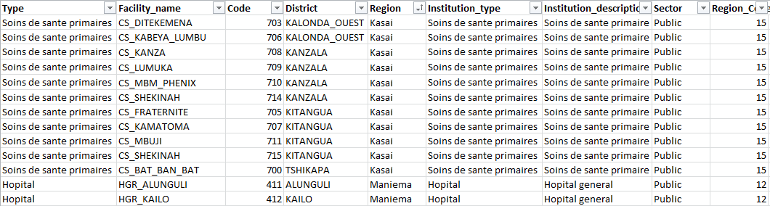

Figure 1.1: Extract from facilities.xls

We allocated a unique code to each facility to enable us to identify the region where it is located as well as the type of facility. This makes it easier eventually to group your files per region or per facility type.

### Setting up the service statistics

We received the service statistics per facility and consolidated all into one file we named the **activities.xls** file. We used this file to do spot checks for data quality by comparing source documents at some facilities to ensure we use quality service statistics data for the WISN. This file should have a line for each activity per cadre per facility containing the actual number of time the activity was done per annum. Even when an activity was not done at all, we included it with a value of zero.

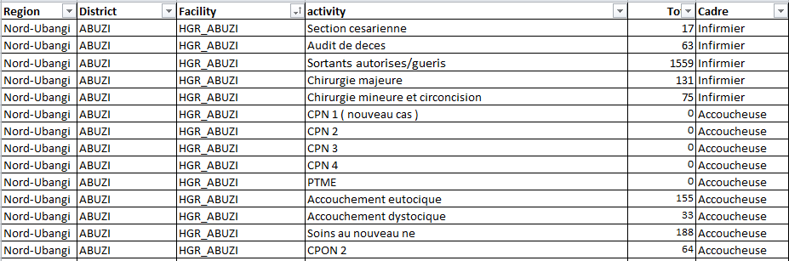

Figure 1.2: Extract from the activities.xls

### Setting up the staff data

We collected the actual number of staff employed per cadre per facility and this became the **staff.xls**.

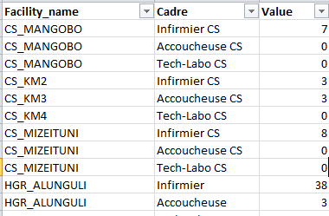

Figure 1.3: staff.xls

You should now have 3 separate input files the WISN Loader requires.

## Preparing to use the WISN Loader

The WISN Loader uses the **Master Facility List (facilities.xls)** to generate the WISN file per facility, and then it uses the **activities.xls** file to update the WISN file with the service statistics. It then generates the WISN file per facility containing the service statistics for the facility and save it using the name in the **Master Facility List (facilities.xls)**.

### Setting up your template files

We set up template files per facility type that contains the WISN activities, activity standards, category allowance standards and individual allowance standards per cadre. WISN does not allow you to set up your own facility types, so we mapped it as follows:

* 1. Hopital for District
  2. Soins de sante primaires for health centers.

You could set the template files up from scratch by starting a new WISN study, or you could open an existing project and save it with the required name. I will take you through both options below.

1. **Starting a new WISN study**
   1. Firstly set up your geographical information (regions and districts) and staff types in the Dictionary manager.
   2. Next set up your facility properties and select country information (these are pre-defined in WISN), region/province and district (you’ve set these up in the step above), institution name, type and description. For the template be sure to use the correct type – refer to 1.2.2 if you’re not sure what I am referring to.
   3. Next, select the type of staff to be included in your WISN study. If a cadre is not selected, you will not be able to define any of the other WISN variables required to calculate staffing requirement such as WISN activities, category allowance standards and individual allowance standards.
   4. Next, set up the available working time per cadre.
   5. Next, set up your WISN activities per cadre on the <Workload Statistics> tab. These are the activities you have service statistics for. There are some standard activities in the tool – if you do not want them to show up in your activity standards, make sure “No per year” is set to 0. Enter 1 as the “No per year” for those WISN activities you want to set up activity standards for in the next step. Enter all your WISN activities before you go to the next step. WISN is case sensitive so be sure to use the same case as in your **activities.xls** - refer to 1.2.3 for more information on this file.
   6. Next, set up your activity standards, category allowance standards and individual allowance standards on the <Activity Standards> tab. You have to select the type of staff you are entering standards for.
   7. Final step is to save your template files with the following names (for DRC case study):

* Hopital
* Soins de santé primaires

hopital.wat is the template for DistrictHospitals and soins_de_sante_primaires.wat is the template for health centers.

1. **Updating an existing study**
   1. Check to see that your geographical information (regions and districts) and staff types have been set up in the Dictionary manager.
   2. Next check your facility properties, country information (these are pre-defined in WISN), region/province and district (you’ve set these up in the step above), institution name, type and description. For the template be sure to use the correct type – refer to 1.2.2 if you’re not sure what I am referring to.
   3. Next, check you have selected the type of staff to be included in your WISN study. If a cadre is not selected, you will not be able to define any of the other WISN variables required to calculate staffing requirement such as WISN activities, category allowance standards and individual allowance standards.
   4. Next, check that your available working time per cadre had been set up.
   5. Next, check your WISN activities per cadre on the <Workload Statistics> tab against your **Master Service Standards** – refer to 1.2.1. Ensure the activities you want to enter standards for, have 1 as the “No per year”. Enter all your WISN activities before you go to the next step. WISN is case sensitive so be sure to use the same case as in your **activities.xls** - refer to 1.2.3 for more information on this file.
   6. Next, check that your activity standards, category allowance standards and individual allowance standards are set up on the <Activity Standards> tab. You have to select the type of staff you are entering standards for.
   7. Final step is to save your template files with the following names:

* hopital
* soins de santé primaires

### Running the WISN Loader

Currently the Loader requires the Java developer environment to run, so you need IT software expertise to use the tool.

## Analyzing your WISN files

This section is not intended to tell you how to analyze your WISN data, but to share some practical tips you can use that will enable you to run summary reports per facility type across regions or vice versa.

The Loader save the WISN files in subfolders per type of facility i.e.

* + - Hopital
    - soins de sante primaires

When you want to compares WISN outcomes amongst facility types, the default folder structure will suffice. However, if you want to compare WISN outcomes amongst facilities within a region or within a region amongst facilities, you have to copy the WISN files in a different folder structure. This is because to compare WISN outcomes, you have to run a summary report and the tool requires all the files to be in the same folder.

To run a summary report for all facilities within a region, create a folder for each region and copy all the files for that region in that folder. Because of the facility type code included in the file name, you will be able to sort your facilities within the WISN tool per file name by clicking on the File Name column and only select specific facilities.

To run national summary reports to compare facilities across regions, create one folder and copy all the files in that folder.